# CI224 Unity Game Development

**Game title:** Ice Cream Simulator

**Genre**: VR Simulator, slice of life, arcade.

( Goal of the game is to make as much money as you can selling ice cream from a van.

Two main sources of money will be scoops of ice cream & Mr whippy cones

Gameplay will include scooping ice cream onto cones and out of tubs, creating 99 flake ice cream cones, and moving around the city to get more customers.

Each customer will have a countdown timer till they get angry at how long you’re taking, and different locations will have different amounts of customers.

Different times of day mean different amounts of people in certain locations. E.g. After 3pm outside school becomes busy

As you sell ice cream you can use your money to upgrade your tuck and buy new ice cream or items. E.g. sprinkles, an ice cream freezer to keep one cone ready for the next customer.

) Original game idea/ brief

**Game Rules:**

The player will be running an Ice Cream Shop/Van and they must do this by creating and giving ice cream cones to customers within a certain time. The customer will ask the player for a specific flavour which they must provide, or they will get no points. The player will have 5 minutes to get as many points as they can.

**Core mechanics:**

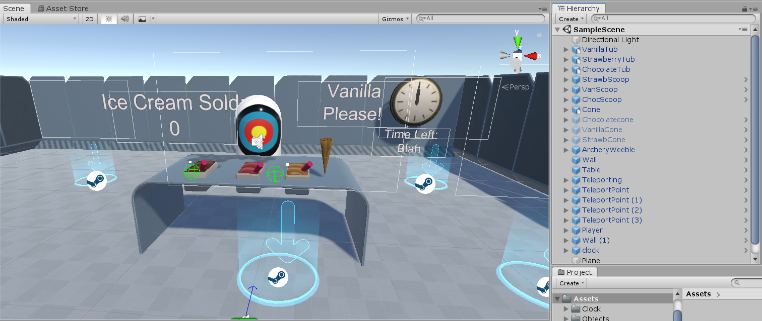Core mechanics currently include scooping ice cream, putting the ice cream on the cone, & giving it to the customer. Currently the customer is an archery target and you must throw the ice cream at it to get the points. The customer will randomly ask for another flavour (which could be the same depending on RNG) when given an ice cream.

**How I’ve implemented gameplay:**

To implement the gameplay for my project I have used samples that come with SteamVR and adapted them so that they fit into what I am creating. For example, The Ice Cream Scoop has some of the most basic scripts attached that only allow the player to pick it up and then when the player lets go the scoop will go back to position. 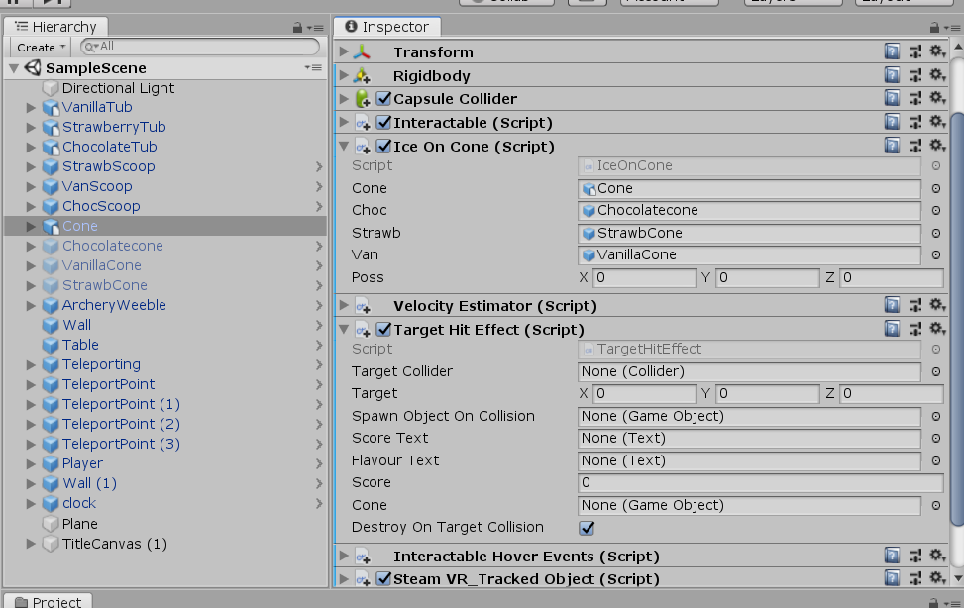

Any interactable item in the VR space has to have specific scripts to allows the Controls to interact.

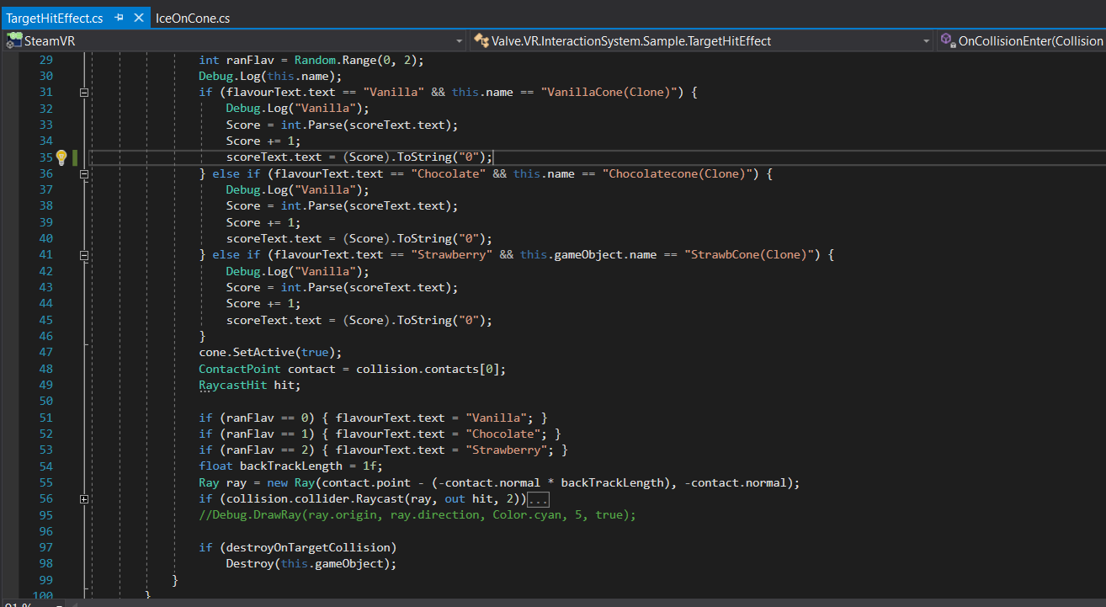With the scripts that I have edited and written for myself I have not done anything with the VR functionality because SteamVR comes with everything you need already. As such the only code I have written for myself is what I’d have to write for any 3D game. For example when putting the ice cream scoop on the cone I had to write a script which checked for collision and then depending what the player is holding it will instantiate a new cone with the correct ice cream. As well as that I created a script which removed the cone when ‘handed’ to the ‘customer’ and created a new cone for the player to create a new ice cream.

**How I would improve the game given more time & knowledge:**

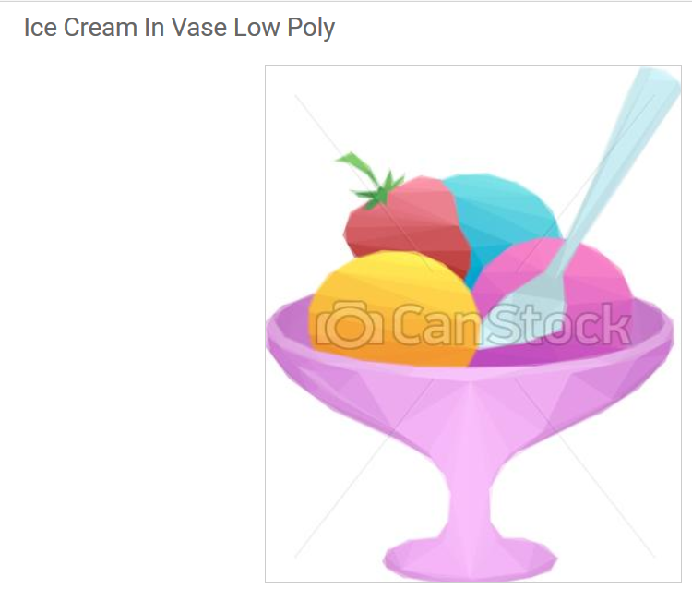The first part of my game that I would improve would be the aesthetic and assets of the game. It would suit a bright and low-poly asset group because the game is meant to be fun and cheery.

The second part I would change is having different kinds of ice cream and cones that the player can use if the customer asks. Possibly an ice cream machine which would give the player more of a challenge to use and could better implement the benefits of Virtual Reality.

The third part I would change is the story gameplay I have created. Originally, I had intended for the play to be able to go to different locations which would have different customers. As well as that when the day/timer ends the player could use the money they had earned to upgrade parts of their ice cream van. This could be unlocking more flavours, having more storage for ice cream, etc, etc.

**Conclusion:**

This project has taught me a lot about how to implement games in VR as it is very similar to implementing a 3D game as Unity handles all the VR aspects for you. I expect if I’d wanted to do something more complicated I would not have found this to be the case however with the project I have produced the sample scripts have been more than adequate. Overall I have produced a good product that has shown my skills and also has good potential for improvement should I return to the project.